
Център за обучение по софтуерно тестване Website: http://skillo-bg.com
Bug Template
Bug ID | PSB002
Name | Incorrectly adding items when "-" appears in the quantity field
Priority | P1
Severity | S1
Description | The field “quantity” must contain only digits
Steps to reproducethe field must not contain symbols but only digits | 1.Load URL: http://automationpractice.com/index.php?id_product=1&controller=product  2.In the field quantity we fill “9+3” and push the button “add to card”  Expected result: The field Quantity must contain only digits  Actual result: The field Quantity contain digits and symbols, but show the first digit in the field
Attachment | 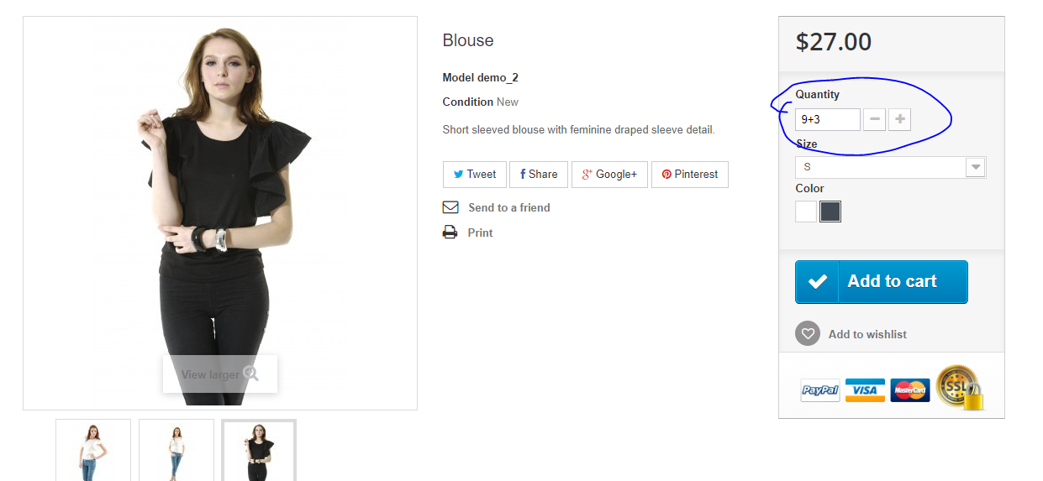
Status | Opened
Component | Basket
Version/Build number (Found in) | 1.7 ver
Environment | Windows 10
Comments | The field “quantity” mustn't contain symbols- only digits
Date Created | 16/04/2019
Author | D. Veselinov
Audit Log

